From our friends at Milestones Autism Resources.
See full details regarding this event at: https://www.milestonesconference.org/
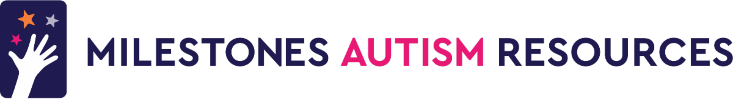
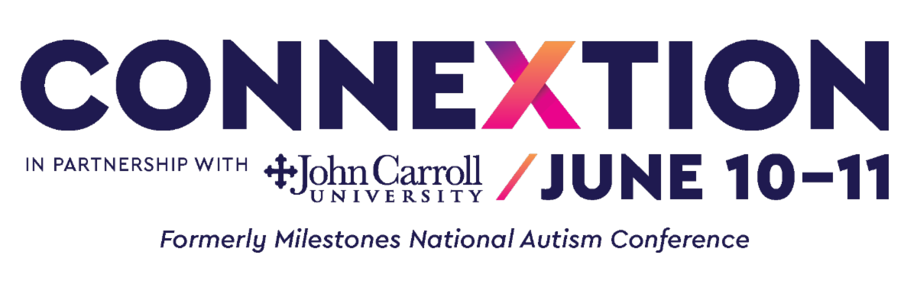
Big News! The ConneXtion Schedule is Coming to Life 🌟
📍 June 10–11, 2025 | Cleveland, OH

We’re excited to share new details about ConneXtion — your go-to event for all things autism support, advocacy, and community. Whether you're coming for the networking, the learning, or the fun, there’s something for everyone at this inclusive, energizing two-day experience.
Here’s a sneak peek at what’s new and confirmed:
Family-Friendly Workshops & Experiences
Tailspinner's Movement Class – For kids and adults of all abilities
The Positivity Spectrum – Help your child thrive this summer: ESY guidance, summer camp planning, and funding tips
RTA Public Transportation Workshop – Learn to navigate public transit with confidence and ease
The Ohio Network for Innovation: Dungeons, Dragons & Decisions – A choose-your-own-adventure style game focused on supported decision-making
Mother2Mother Caregiver Meet-Up – Connect with fellow caregivers in a supportive space
Teen Room – A dedicated hangout just for teens
Dungeons & Dragons Game/Meetup for Beginners – Join us for an all-ages tabletop journey
Autistic Job Fair – Hosted by Cuyahoga County Board of DD’s Workforce Development Team

Live Music
Folk Ability will perform on Day One!

Get Ready to Eat Well at Food Trucks on BOTH DAYS
Freaky Fruits
Braised in the CLE – See them on the Today Show!
Blasian Fusion
MORE ANNOUNCEMENTS COMING SOON!

Haven’t registered yet? What are you waiting for?!
Be part of an event that redefines community connection and reimagines autism support. From engaging workshops to hands-on resources and inspiring entertainment — ConneXtion is your space to learn, grow, and belong.

👉 Register Now

Warmly,
The Milestones Team
(216) 464-7600 | www.milestonesconference.org

