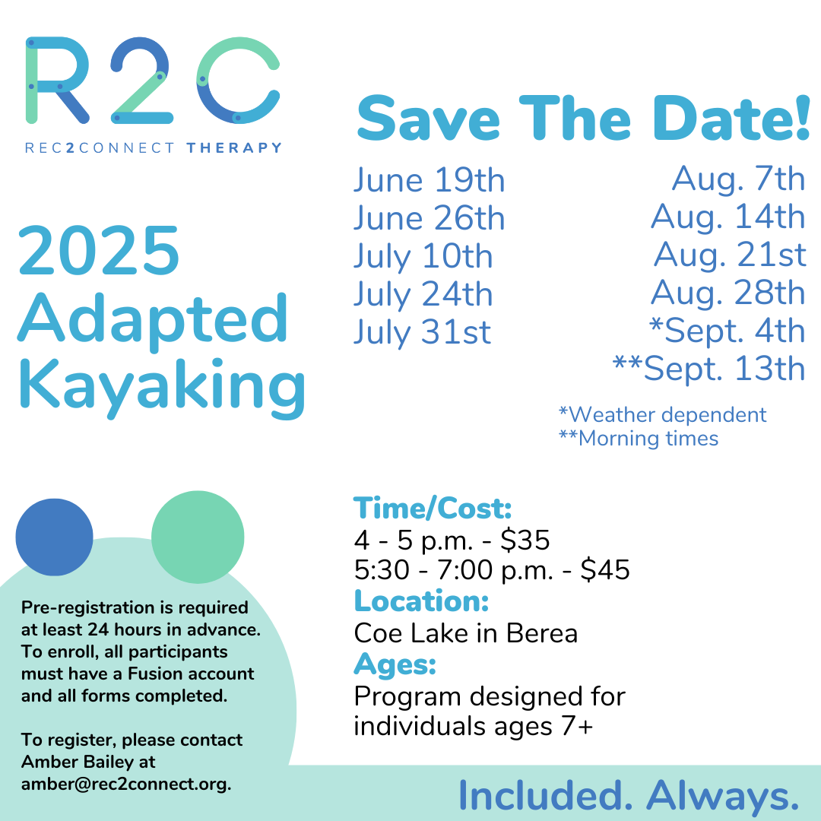

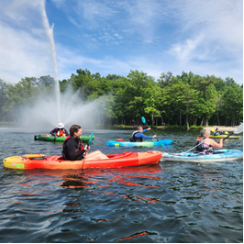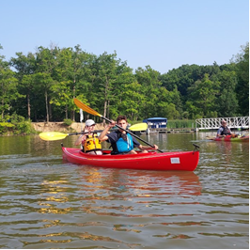

That's right - one of everyone's favorite Rec2Connect programs is ready for the 2025 season!
Our Short and Long Kayak programs will begin in June and continue throughout September.
This is a beginner level kayak program that occurs on Thursday evenings throughout the summer. Participants will focus on both entry-level kayaking skills and entry-level to moderate kayaking skills while building problem-solving and social skills!
Our program is designed for ages 7 and up. Please see the above flier for cost, location and registration information.
Please keep an eye out for more information regarding our 2025 Family Kayak Program as well!
We can't wait to see you there!

Email Amber to Sign Up!Ages 7

